**Docker Container**

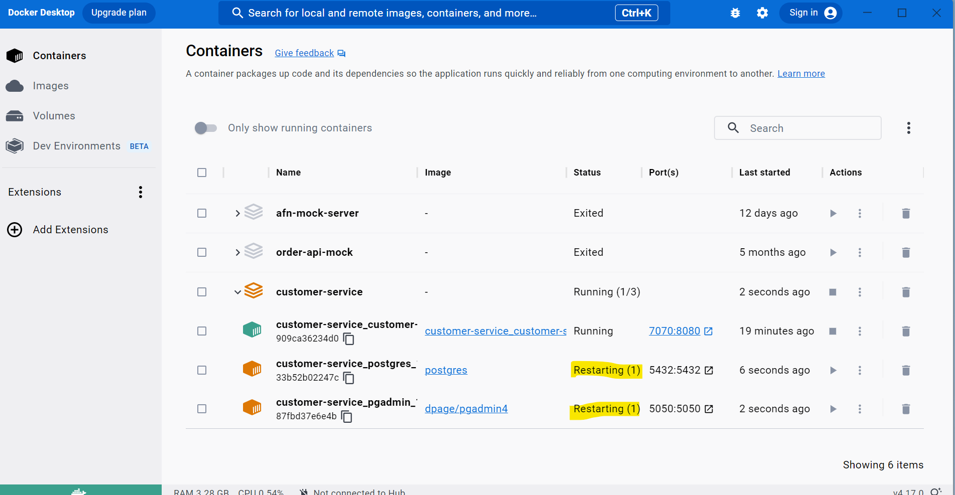

**Errors for Postgres & PGAdmin**

2023-03-22 12:19:34 2023-03-22 06:49:34.893 INFO 7 --- [or-http-epoll-3] c.a.n.c.controller.CustomerController : Request received to get customer details for customerTpe : Corporate

2023-03-22 12:19:44 2023-03-22 06:49:44.944 ERROR 7 --- [tor-tcp-epoll-3] c.a.n.c.controller.CustomerController : Error occurred for customerType Corporate : Failed to obtain R2DBC Connection; nested exception is io.r2dbc.postgresql.PostgresqlConnectionFactory$PostgresConnectionException: Cannot connect to postgres:5432

2023-03-22 12:19:44 2023-03-22 06:49:44.948 ERROR 7 --- [tor-tcp-epoll-3] c.a.n.c.e.CustomExceptionHandler : Failed to obtain R2DBC Connection; nested exception is io.r2dbc.postgresql.PostgresqlConnectionFactory$PostgresConnectionException: Cannot connect to postgres:5432 status code 500 INTERNAL_SERVER_ERROR

#### Postgress #####

Error: Database is uninitialized and superuser password is not specified.

2023-03-22 12:23:59 You must specify POSTGRES_PASSWORD to a non-empty value for the

2023-03-22 12:23:59 superuser. For example, "-e POSTGRES_PASSWORD=password" on "docker run".

2023-03-22 12:23:59

2023-03-22 12:23:59 You may also use "POSTGRES_HOST_AUTH_METHOD=trust" to allow all

2023-03-22 12:23:59 connections without a password. This is *not* recommended.

2023-03-22 12:23:59

2023-03-22 12:23:59 See PostgreSQL documentation about "trust":

2023-03-22 12:23:59 https://www.postgresql.org/docs/current/auth-trust.html

####PGAdmin ####

2023-03-22 12:26:05 You need to define the PGADMIN_DEFAULT_EMAIL and PGADMIN_DEFAULT_PASSWORD or PGADMIN_DEFAULT_PASSWORD_FILE environment variables

**Below docker-compose syntax works**

version: '3.1'

services:

postgres:

image: postgres

restart: always

ports:

- 5432:5432

volumes:

- 'postgres_data:/data/db'

environment:

POSTGRES_INITDB_ROOT_USERNAME: ${POSTGRES_USER}

POSTGRES_INITDB_ROOT_PASSWORD: ${POSTGRES_PASSWORD}

POSTGRES_HOST_AUTH_METHOD: trust

pgadmin:

image: dpage/pgadmin4

restart: always

ports:

- 5050:5050

depends_on:

- postgres

environment:

ME_CONFIG_POSTGRES_ADMINUSERNAME: ${POSTGRES_USER}

ME_CONFIG_POSTGRES_ADMINPASSWORD: ${POSTGRES_PASSWORD}

ME_CONFIG_POSTGRES_PORT: ${POSTGRES_PORT}

ME_CONFIG_POSTGRES_SERVER: ${POSTGRES_HOST}

PGADMIN_DEFAULT_EMAIL: server@myapp.de

PGADMIN_DEFAULT_PASSWORD: XXXX

customer-service:

build:

context: .

dockerfile: Dockerfile

ports:

- 7070:8080

environment:

ENVIRONMENT: ${ENVIRONMENT}

SPRING_BOOT_PROFILE: ${SPRING_BOOT_PROFILE}

POSTGRES_USER: ${POSTGRES_USER}

POSTGRES_PASSWORD: ${POSTGRES_PASSWORD}

POSTGRES_HOST: ${POSTGRES_HOST}

POSTGRES_PORT: ${POSTGRES_PORT}

POSTGRES_NAME: ${POSTGRES_NAME}

LOGGING_LEVEL_API: ${LOGGING_LEVEL_API}

LOGGING_LEVEL_POSTGRES: ${LOGGING_LEVEL_POSTGRES}

volumes:

postgres_data:

driver: local

**Again getting error like below**

2023-03-22 12:48:56 2023-03-22 07:18:56.914 WARN 7 --- [tor-tcp-epoll-5] i.r.p.client.ReactorNettyClient : Error: SEVERITY_LOCALIZED=FATAL, SEVERITY_NON_LOCALIZED=FATAL, CODE=3D000, MESSAGE=**database "reactivedemo" does not exist**, FILE=postinit.c, LINE=941, ROUTINE=InitPostgres

**Note:**

Change your pgAdmin mapping in both file(docker-compose.yml & local.env file)

postgres:

container_name: pg_container

image: postgres

restart: always

ports:

- **5433:5432**

**And then run docker compose up -d –build**

**Open your pgAdmin and register your docker postgres port**

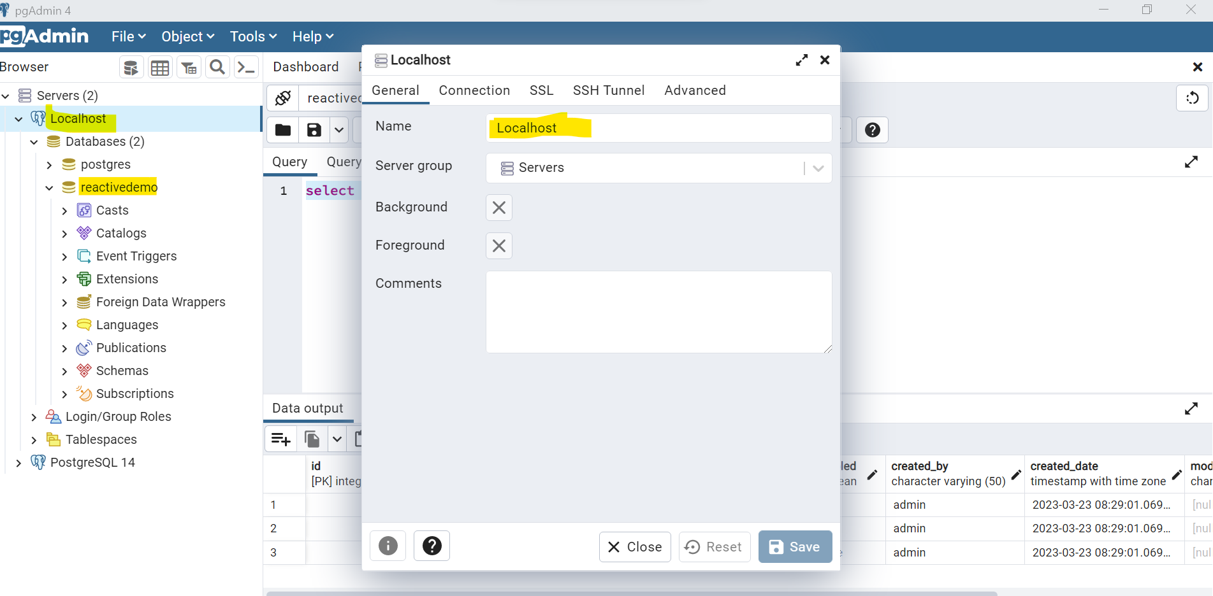

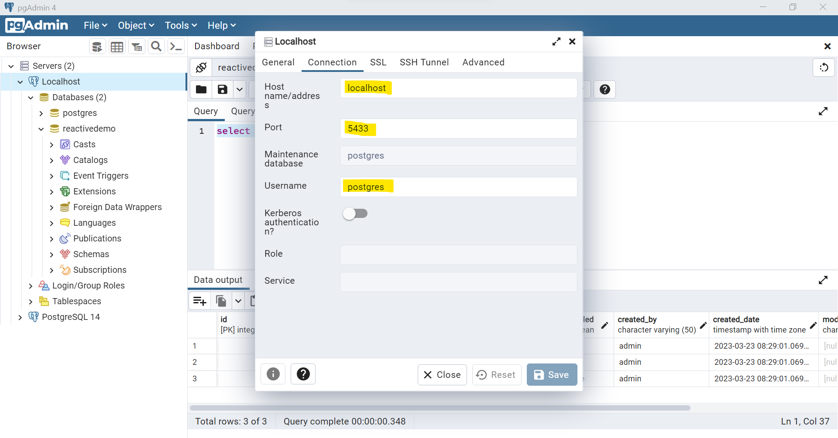

**We can run using docker CLI (windows->PowerShell)**

Setup Postgres Database - Setup Postgres using Docker: https://www.youtube.com/watch?v=3fV-YsQiRAQ

Connect with postgres usign docker CLI command: <https://www.youtube.com/watch?v=VIEkFUmBp6I>

\l : show all the databses

Shell commands for postgres:

https://chartio.com/resources/tutorials/how-to-list-databases-and-tables-in-postgresql-using-psql/

<https://gist.github.com/jessepinkman9900/3f65e33ffd84abc84bd331d464d55c11>

